**Mobile first design:** When we write css for mobile device first, and then use media query for larger screen device, that is called mobile first design. It is the recommended way.

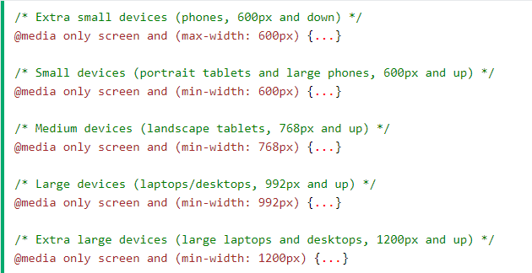

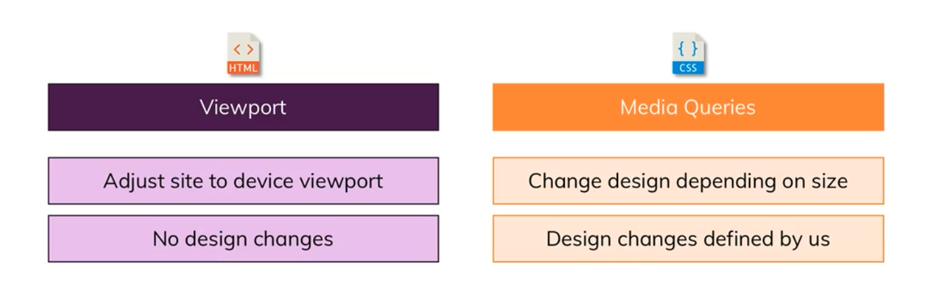

**Viewport:**

<meta name="viewport" content="width=device-width, initial-scale=1.0">

* the **name** targets the viewport.
* **Content** property value makes sure browser knows the device hardware width
* **Initial-scale** defines the starting zoom level.
* We can define max zoom level with **maximum-scale** attribute.
* We can define min zoom level with **minimum-scale** attribute.

**Media Queries:**

* Order matters since css specificity is most for the last element. So if we specify the bigger min-width media query first, then the last media query will take precedence. And the other media query wont work.
* We can define different media types, such as printer, speech, screen or all.
* As for media feature there is a big list. Check w3schools for reference.
* We can use logical media query to make sure things work well in portrait mode as well. Need to practice more on this since I skipped it.